MARC PERAL CAJIDOS

sa palomera 2023-2024

OVO

DAW Final project

Content

Introduction 3

Important Links 3

Functional Requirements 3

Login and Register 5

Local Disk Libraries 5

Movie Metadata from external API 5

Custom Video Player 5

Multiple Database Support 5

Admin Panel 5

Sync Play 5

Technical Requirements 6

Developer 6

User 6

Diagrams 7

Use case 7

Anonymous 7

Admin 7

User (Authenticated) 7

Activity 8

Visitor 8

User 9

Admin 13

Interfaces 14

Wireframe 14

Mock-up 14

Classes 16

Database 18

Implementation 19

Database 20

Video files 20

Metadata 20

Cross site components 22

Sidebar 22

Syncplay menu 22

Pages 23

Homepage 23

Library 24

Item details 25

Unit Testing 26

Deployment 26

Improvement proposals 28

Conclusions 28

Webography 29

Documentation and help 29

Tooling 29

Resources 29

# Introduction

Back in the days where there was no Netflix or any other video streaming, people usually had their own media library. Containing boxes of movies or seasons of a TV show. Today, although the vast majority uses video streaming for a regular basis, some still prefer to own their content, so they still have a physical library.

This project aims to that people that still own their content, and have a physical based library. We can help and improve their media consumption experience by making possible to consume it at any time anywhere as long as there is an internet connection.

As an extra, we also provide features like checking content as “watched” or “favorited”, find movies or shows by an actor or director, having a synced video player to watch your content with your friends and family, and more to come.

## Important Links

Before start, here are some relevant links to this project

* Shared Folder containing repositories
  + <https://drive.google.com/drive/folders/1zQjLpEI4G9hyR9UfXzk8bc131OZS3oTT?usp=sharing>
* Ready to launch compiled binary
  + <https://mega.nz/folder/o78AXRaa#VRQTWLuMa8LHjBK9-hGCnQ> (Google drive makes the file inaccessible due to an existing .exe inside)
    - The ready to launch file, contains the binary file, env file and some video files to test out the project. Note that still requires FFmpeg installed.
* Code repo:
  + (Private, needs invitation) <https://github.com/mperalsapa/ovo>
* Documentation Repo
  + <https://github.com/mperalsapa/projecte-final-daw>
* Deployed demo
  + <https://demo1.ovo.watch>
  + Admin credentials are
    - User: Admin
    - Password: P@t@t4

# Functional Requirements

The following roadmap specifies the technical and functional requirements for the site. This includes both frontend and backend functionality.

* Responsive frontend (Mobile, Tablet, Desktop)
* Login and Register
* Local Disk Libraries
* Movie Metadata from external API
* Custom Video Player
* Multiple Database Support
* Admin Panel
* Sync Play

### Login and Register

#### Login

The user has the ability to login using existing credentials (username and password).

#### Register

Users who do not have an account can register using a username and password. Currently any user registration will be accepted, but it is planned to only activate accounts by the admin of the instance.

### Local Disk Libraries

Admin can use admin panel to add searching paths to index movies and make them accessible. For example:

An instance of the server has access to /mnt/movies, but the admin only wants to index some folders. The admin can configure indexing paths to use

* /mnt/movies/christmas
* /mnt/movies/halloween

In that case, only those two folders would be indexed and the system would treat as a single one.

### Movie Metadata from external API

During a content directory scan, it will try to match real content in order to fetch metadata.

Currently the only metadata provider is The Movie Database (TMDB)

### Custom Video Player

A custom video player that plays the content from the site.

### Multiple Database Support

The service has the compatibility with multiple databases. This can be but not only:

* SQLite 3
* MySQL
* PostgreSQL

This is possible due to the GORM package used in the server, that has support for many databases, as stated [here](https://gorm.io/docs/connecting_to_the_database.html).

### Admin Panel

Here a user with privileges, could add or modify libraries.

### Sync Play

This will enable the custom player to be synced to watch content with other users within the site. For example, Sync Play on a movie, will sync the video player of those who are in group (one user pausing will pause everyone's player, same for scrubbing, etc...).

Any user can create, join or leave a group.

# Technical Requirements

## Developer

The following requirements are required (some are optional) to run in a development environment.

* Backend
  + GO 1.22
    - [Templ](https://templ.guide/quick-start/installation) (Template generator CLI tool)
  + Database (Supported by GORM, could be SQLite, MySQL, PostgreSQL)
  + Sass
  + Node.js
  + [FFmpeg](https://ffmpeg.org/download.html#build-windows) installed in PATH
  + Air (Optional, reloads runtime on file change)
* Frontend
  + jQuery
  + Google Icons
  + Sweetalert2
  + Isotope
  + ImagesLoaded

## User

The following requirements are needed for this project to work in a production environment.

* Server runtime (one of the following options)
  + Binary file (GO program compiled containing the backend and the frontend)
    - Binary file requires to have [FFmpeg](https://ffmpeg.org/download.html#build-windows) installed in PATH
  + Docker image (Using source code Dockerfile)
* Database (Supported by GORM, could be SQLite, MySQL, PostgreSQL)

# Diagrams

## Use case

### Anonymous

Anonymous user can only login or register. In context of the app, the only notable action would be login, because that action moves his role into a user for further interactions.

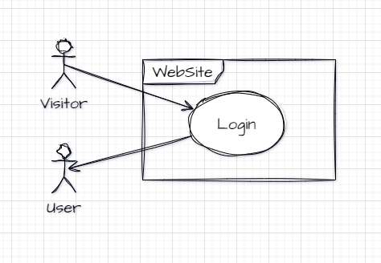

### Admin

An admin in the admin panel, can list, create, modify or delete libraries.

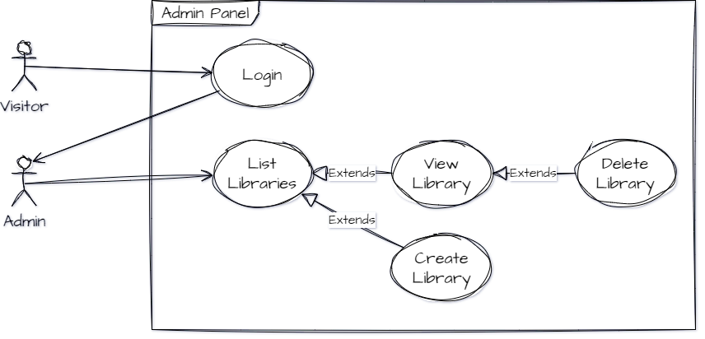

### User (Authenticated)

A user can list libraries and items in home page. Within that library, can view an item and play that item.

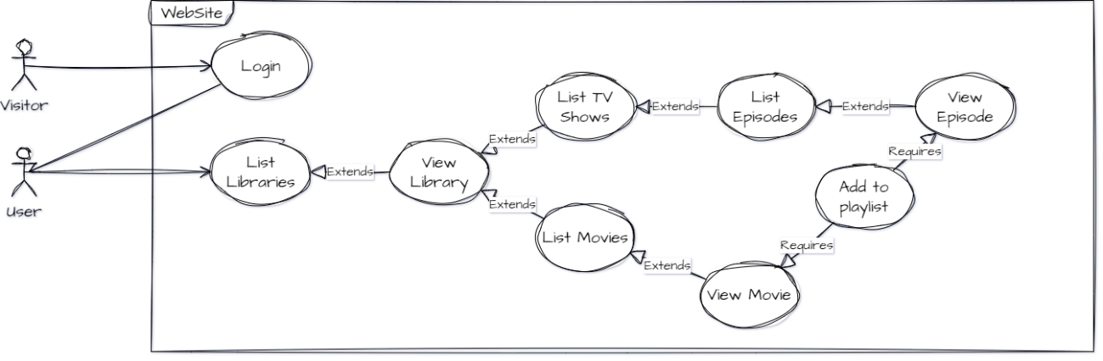

## Activity

### Visitor

A visitor can only login or register.

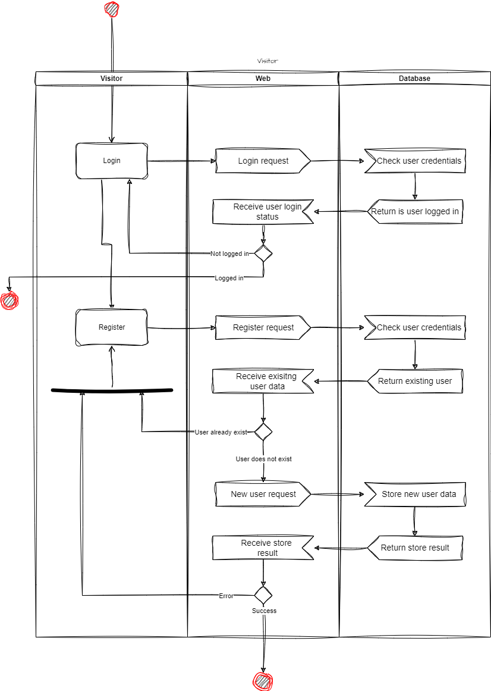

### User

#### Home

User in home can visualize a list of libraries and latest library items.

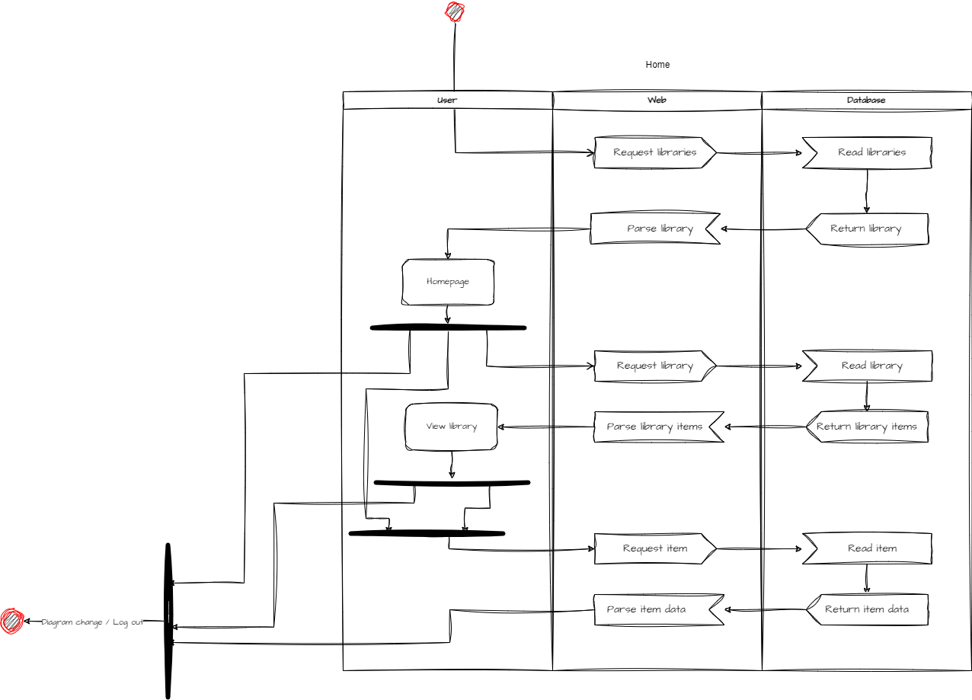

#### Item

Can view an item and the related metadata, mark item as favorited or watched, view a person (cast) profile or play the content.

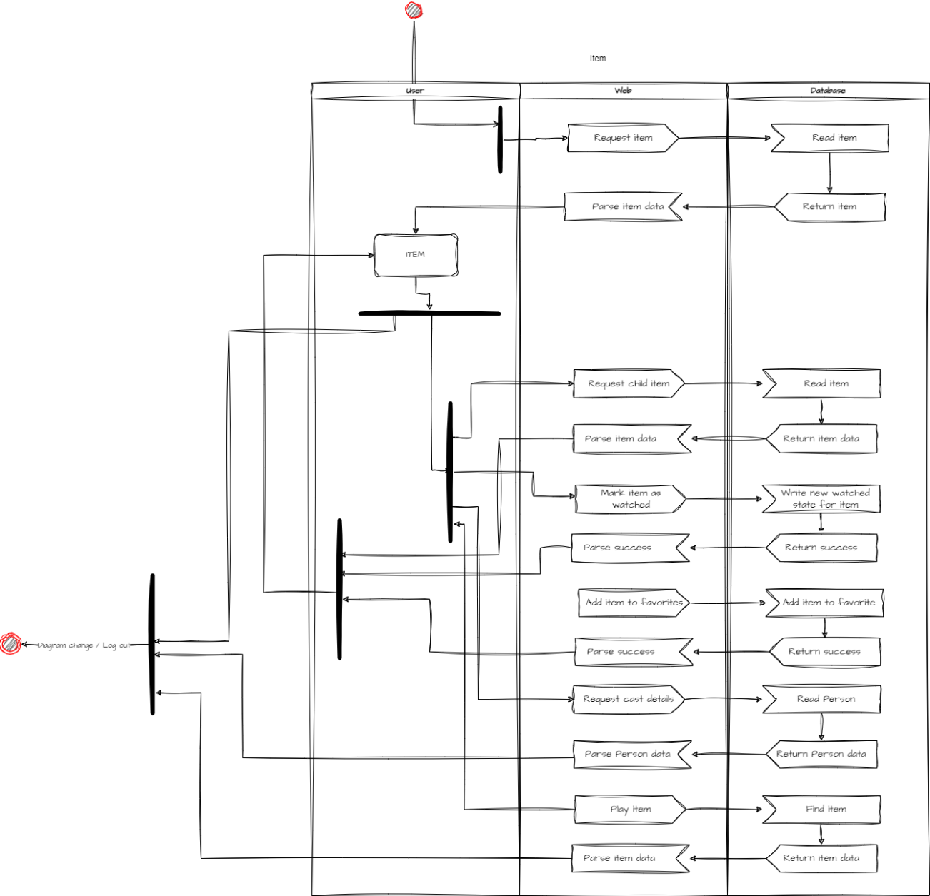

#### Person

From an item, the person profile displays biography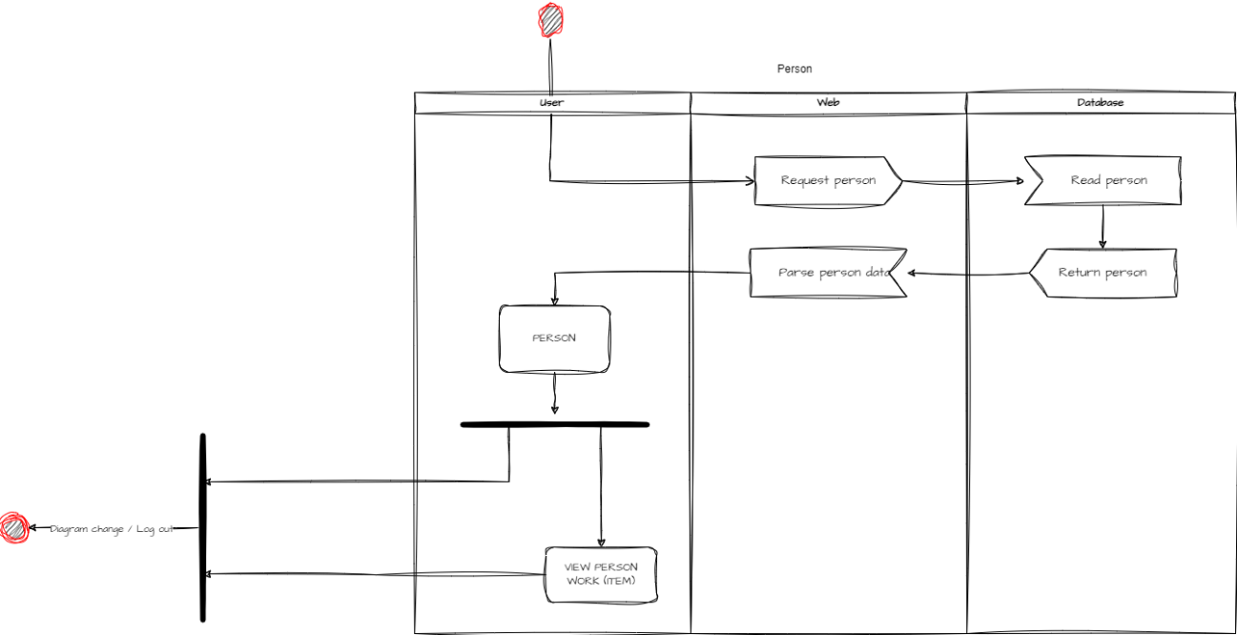

#### Playback

Contained within the video player, this activity is driven by the sync status. If the user is within a sync group, the flow of the activity is different.

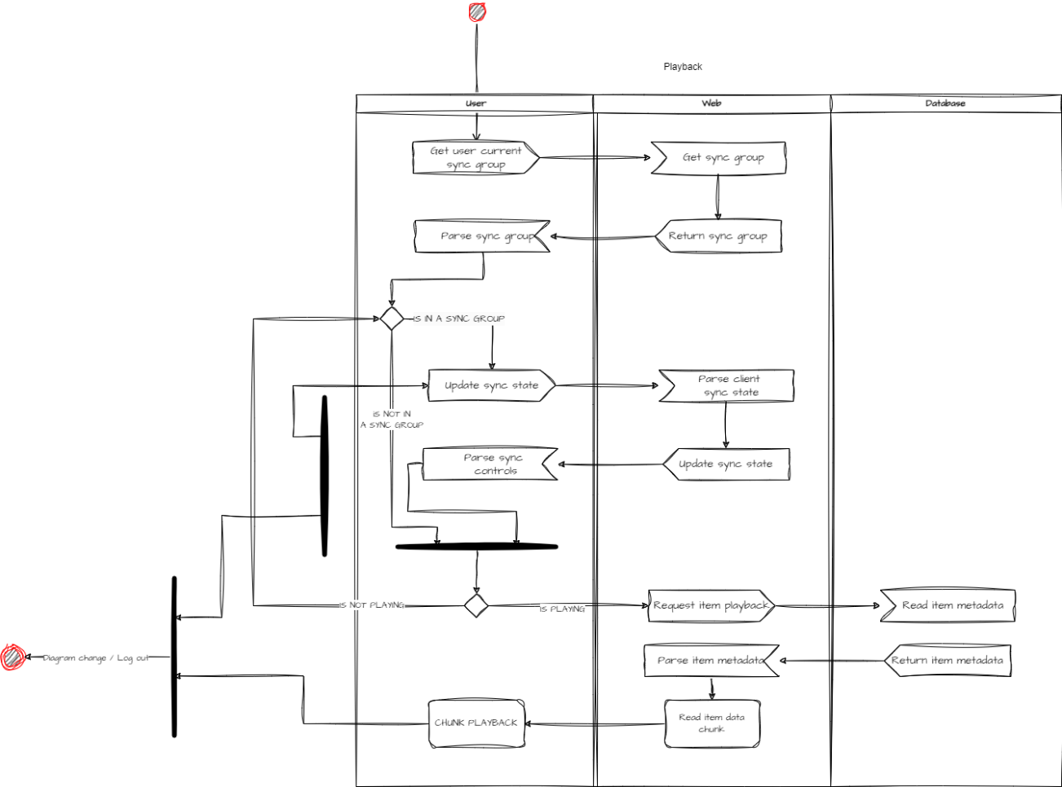

#### Sync Play

Part of the Sync Play is related to this diagram. Here a user can create, join or leave a sync group anywhere on the site.

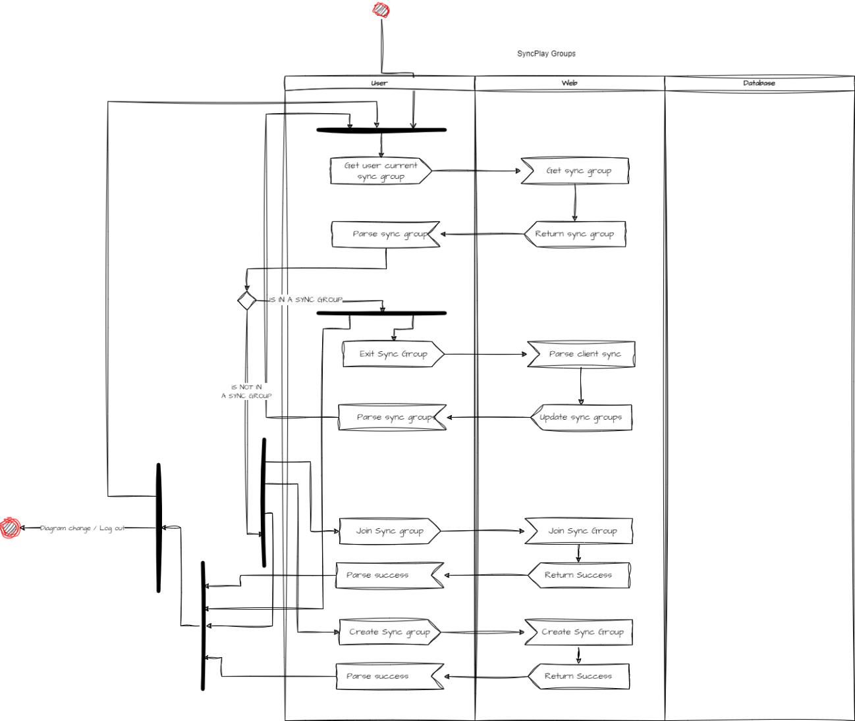

### Admin

The admin activity can be the following.

A user can access the admin panel if the role is admin.

Within the dashboard, the admin can request the current libraries, and modify or delete existing ones. Can also create new ones. Finally, the admin can scan the listed libraries to discover new, removed or modified content and update the database and metadata.

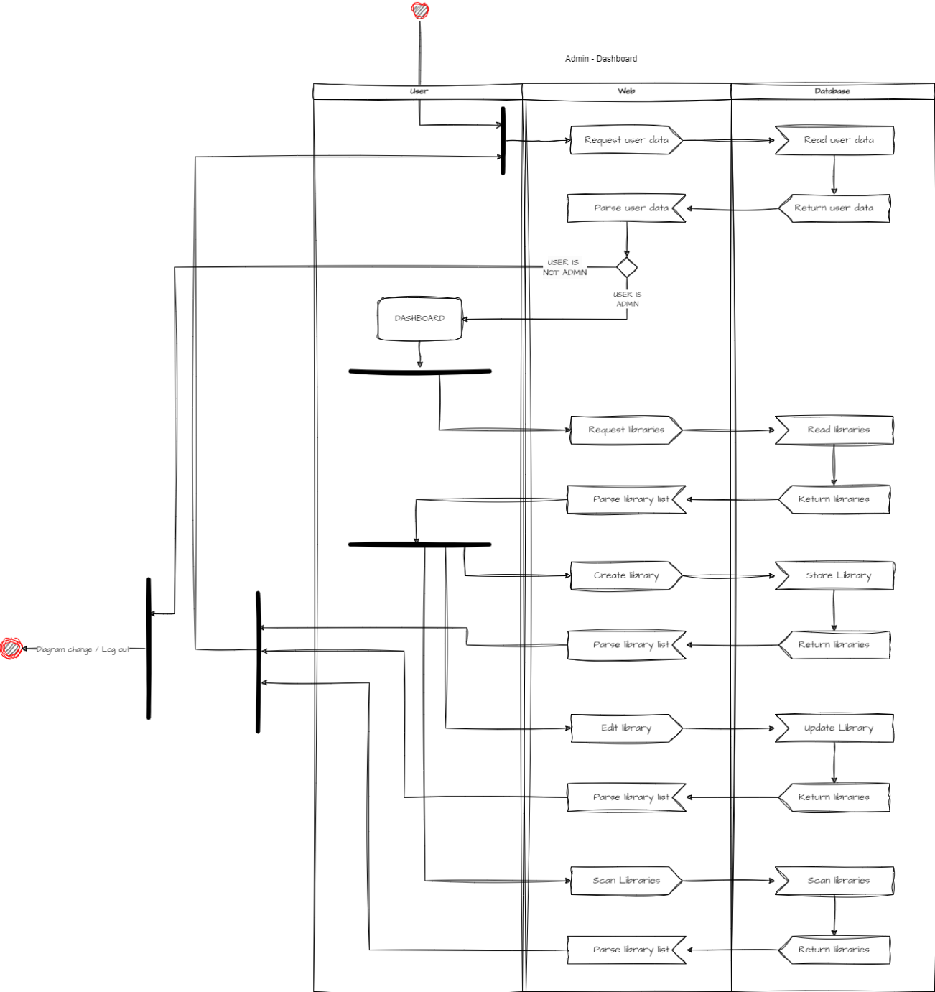

## Interfaces

### Wireframe

The project wireframe is available on a [Figma file](https://www.figma.com/file/aCbIxzpaxcp6AcK81DXtMA/OVO?type=design&node-id=1%3A6&mode=design&t=XCCFpA34dZMLbMfa-1)

### Mock-up

The mock-up was a copy of the wireframe with some extras. But the real test was made in HTML&CSS&JS on a testing project in order to visualize better the effects instead of making assumptions on Figma.

The Figma file can be found [here](https://www.figma.com/design/IfNPP6hXkPsHfpmMQlNgFZ/OVO-Mockup?node-id=0-1&t=7NnfQtD5Pj3zKpn2-1)

Here are some screenshots.

#### Background of the page plus noise plus the scanlines filter

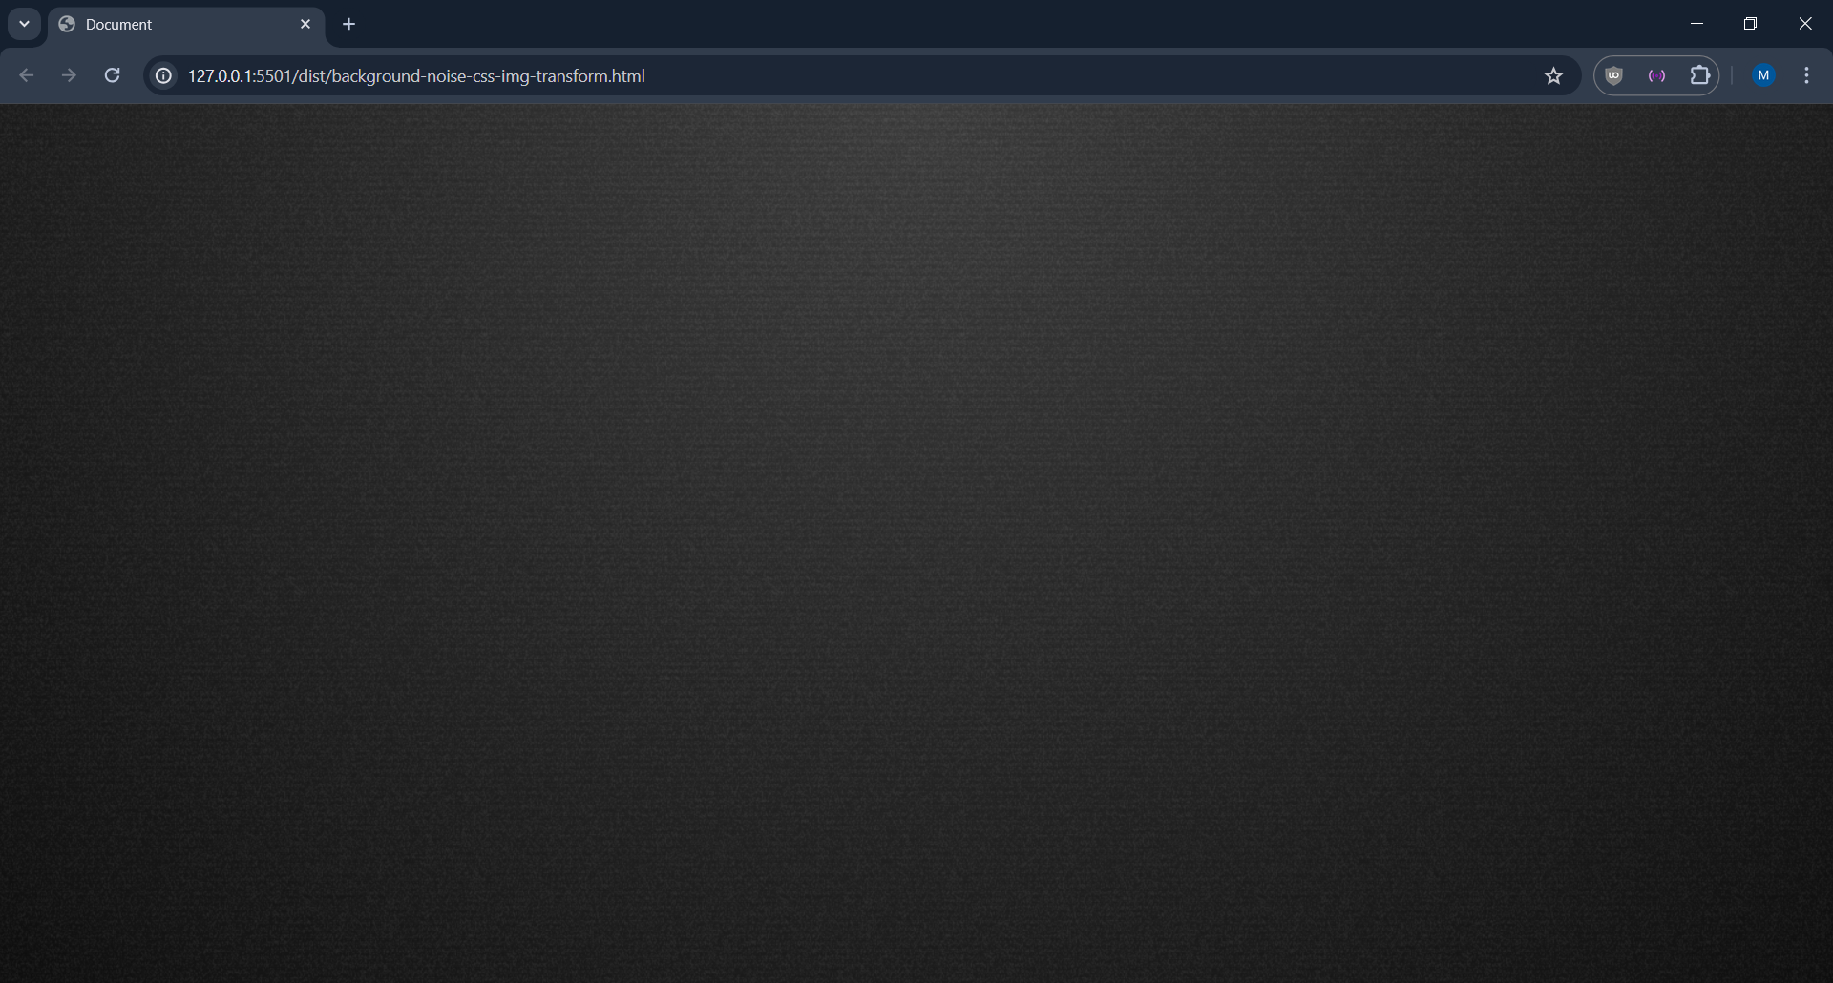

#### Library Page

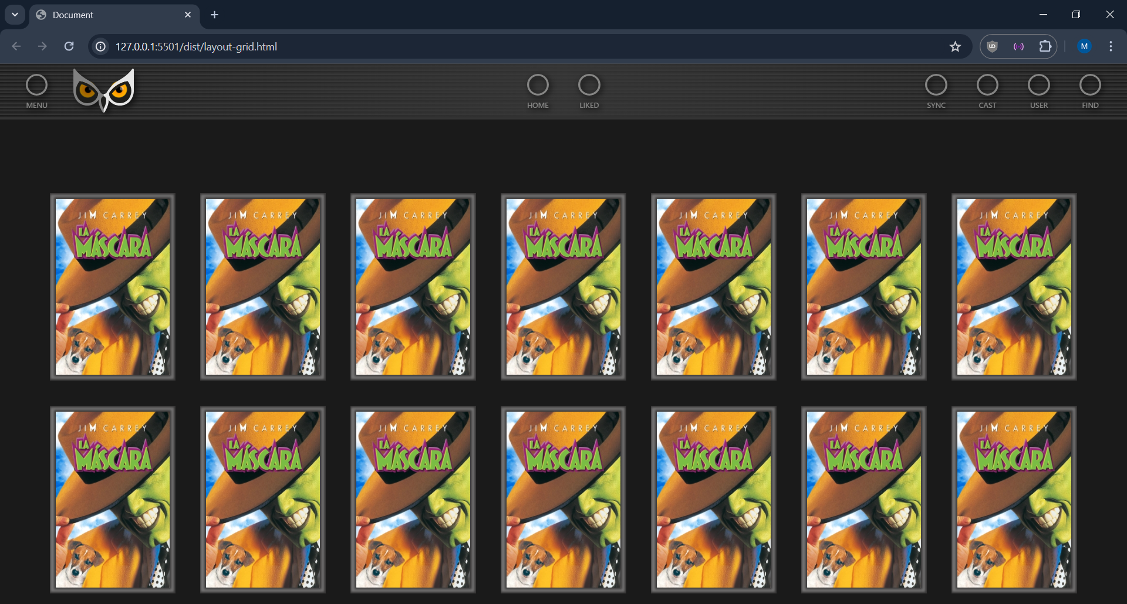

#### Custom Video player

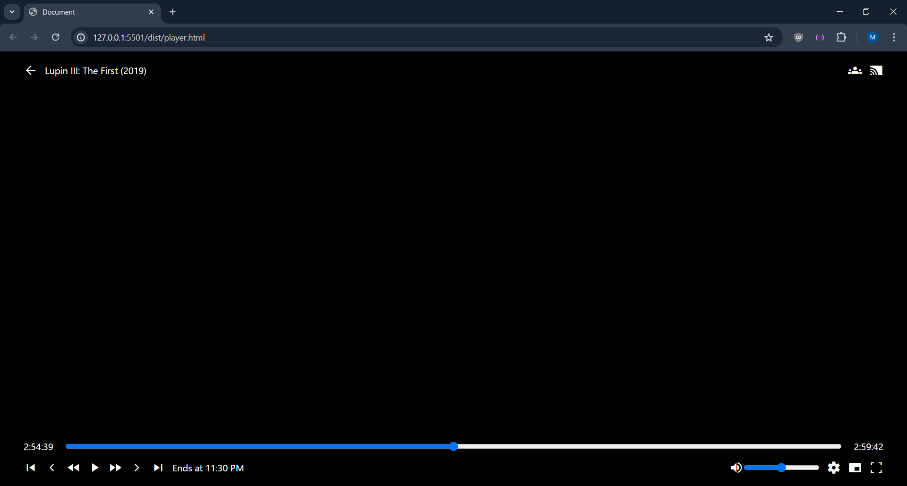

## Classes

[The class diagram](https://raw.githubusercontent.com/mperalsapa/projecte-final-daw/main/Diagrams/Class/Class.svg) is too big to be placed in this document. Can be found in the documentation repository.

On this diagram, you can see each module and inside each “class”. The architecture of the project is based on MVC, where a module controls the view, another the model, and another the controller.

Over this, we have a main package that assembles all modules.

The architecture could be explained in the following definitions:

* **Main**: The main package that **assembles the project** using internal and external modules. This module is the one that starts the web server, registers the routes and calls de controller when new request come.
* **Config**: Used to define **server configurations**, like database type, basepath URL, etc…
* **Router**: This package has the purpose of **registering routes** in a single place for later usage in any package. A route can be defined, for example “user profile” as “/user/profile”, and other packages (like main) can read that data.
* **Session**: Custom package in charge of **user sessions**. This package reads the session of a user (currently stored in a cookie, but can be anywhere) and makes the data within that session accessible and writable.
* **Database**: This package uses an external package to build a connection to a database. The type of database is provided by environment settings, previously loaded by the config package. It also makes accessible **the database connection** for other packages consumption.
* **Controller** & **ApiController**: Manager of valid network requests. This package contains **functions** that perform actions (like retrieve or update data) and / or **render pages**.
* **Model**: In charge of the whole app **data control**. This package is the one that reads from database and creates instances of objects like “User, Item, Library, etc…”
* **File**: Used to interact with the server filesystem and the bundled content.
* **Tmdb**: Custom built package to interact with an external package that provides an API for TMDB REST API.
* **Websocket**: Package that manages WebSocket upgrades and connections from a HTTP endpoint. This package is tightly built to interact with **Syncplay** package to provide player synchronization functionality, making possible to parse commands from clients, update sync state and updating clients of current state.
* **Syncplay**: As stated previously, this package is responsible for the Syncplay functionality. It manages the state of sync and makes it accessible for other packages like **Websocket** or a controller (e.g.: ApiController).

Finally, we have the “Frontend” packages. Note that frontend is quoted, because we perform server-side rendering.

* **Component**: Package that provides HTML, CSS and JS **components for other packages** in order to repeat as little code as possible.
* **Shared**: This package provides what could be considered a component, but only contains the Page itself, for example, the **component that contains the Header** section of an HTML document.
* **Page**: Providing functions to render pages using component and shared functions to build pages. **This is the main** calling for a **render** when a request is processed in a controller.

## Database

This was the **initial** database schema. Here we can see that some entities like a Show or a Movie are in a separated context, with their own table and relations.

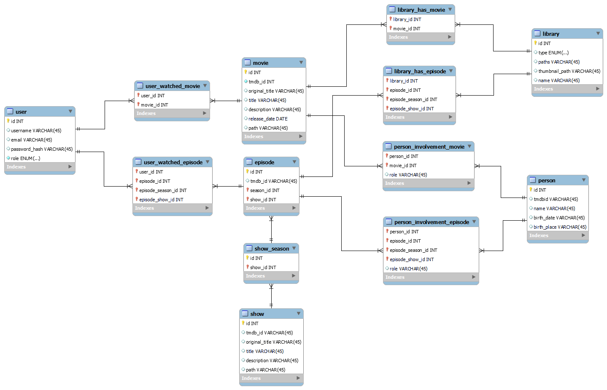

This is the **v3** of the database, the current state. Here we can see that a simplification work has been done. Now any entity like a movie, episode, show, are an “Item” entity. This moves the complexity from the database to the backend.

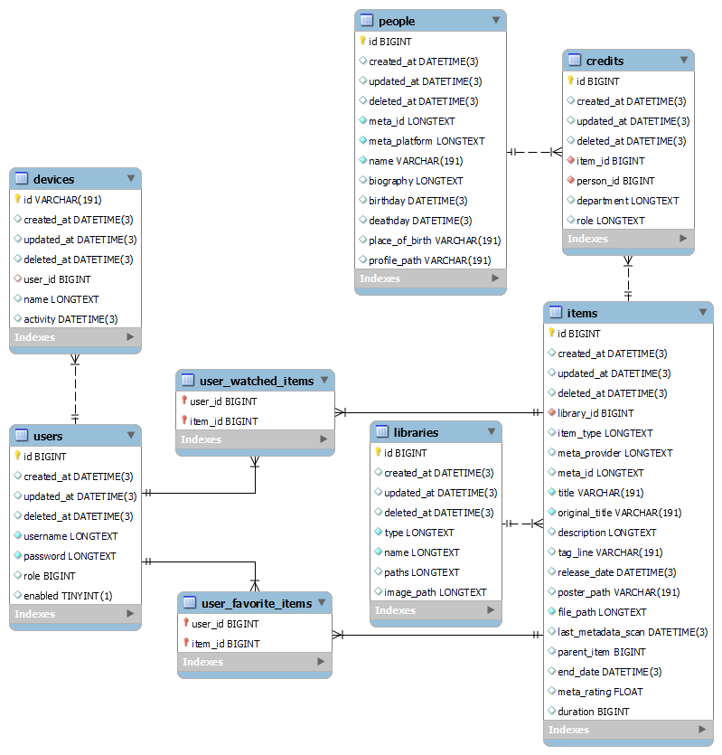

# Implementation

The implementation was a bit **shaky**. From the beginning, this project had in scope to be composited by **two source codes**. One would be the **frontend**, based in React, and the other would be the **backend** using the current stack, without the server-side rendering.

But we soon found that without prior training in **React**, it could be very difficult very fast. So, we opted for **server-side** rendering.

Some of the initial requirements were discarded, not because a change of opinion or focus, but because we preferred to **quality over quantity**.

A **log of what has been done** can be found in the **doc repo**, containing dates, explanations and screenshots.

As an extra, a time tracking has been used for the coding part, and there are tracking of spent time by file and date for the project.

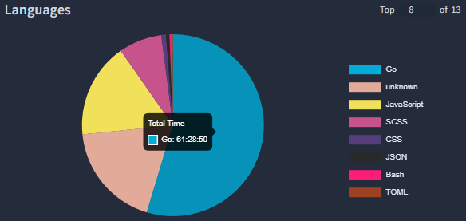

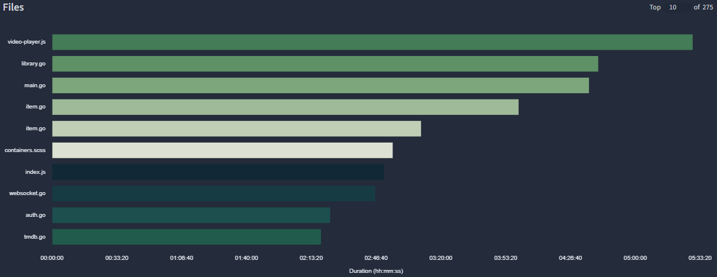

NOTE: This only accounts for the writing and modifying text of the source code. This means that usually, **when working on a feature 1/3 or 1/2 of the time, there is no typing**. Also, **the “unknown” language, is Templ**, the used language for the template engine.

## Database

This project implemented the multi database focus. This means that we aim to support multiple SQL databases. The following are supported:

* SQLite
* MySQL
* PostgreSQL
* SQLServer

The previous list show full support, but other (e.g. MySQL compatible databases) may be compatibles.

The database gives a wide range of accessibility for any deploy for any size. In an instance with very few users, SQLite could be used, contrary to a big one that could use a MySQL server.

## Video files

Because this project is about movies and shows, video files are a very important concept. When scanning libraries, we follow the next steps:

1. Scan library paths to get files (folders in case of shows and seasons)
2. Scan for new items
   1. Checks if the scanned file is within the database
3. Deduplicate
   1. Deletes duplicates within the same library.
4. Remove orphan items
   1. Checks if every library item exists. In case of inexistence, removes it from the database
5. Fetch item metadata from TMDB
   1. Downloading the item metadata, and their related people, like the cast, director, etc…
6. Fetch item runtime
   1. Scans the files using FFprobe to get the items duration. In case of a show or a season, grabs their children and adds their runtimes.
7. Get library thumbnail
   1. Gets a random item within that library and gets the poster of that item to be displayed as the library thumbnail in the Home page.

## Metadata

Each item that has a valid name, during a scan, will get its respective metadata. Although sometimes could get metadata from other item that has a similar name and year, that’s relatively unusual, and it is expected to be the user that corrects that behaviour.

When scanning an item, we use its name (provided by the filename) and the year (provided by the filename, if it exists). As a third option, used to specify an item identity, an id can be placed within the item filename as follows: “filename_(2000)_[tmdbid-550].mp4”.

If an id is placed within the filename, the name and year will be ignored completely.

After we have the files local metadata, we perform a search for unknown items. Then we fetch their metadata by the first result. In case we already have an ID, we simply fetch the ID.

For a show or a season situation, we perform a scan like a movie but for shows, seasons and episodes.

## Cross site components

### Sidebar

This component, gives access to the navigation of the site. When the navbar is not enough, here we can see all libraries and other pages like Home, and admin dashboard in case of privileged users.

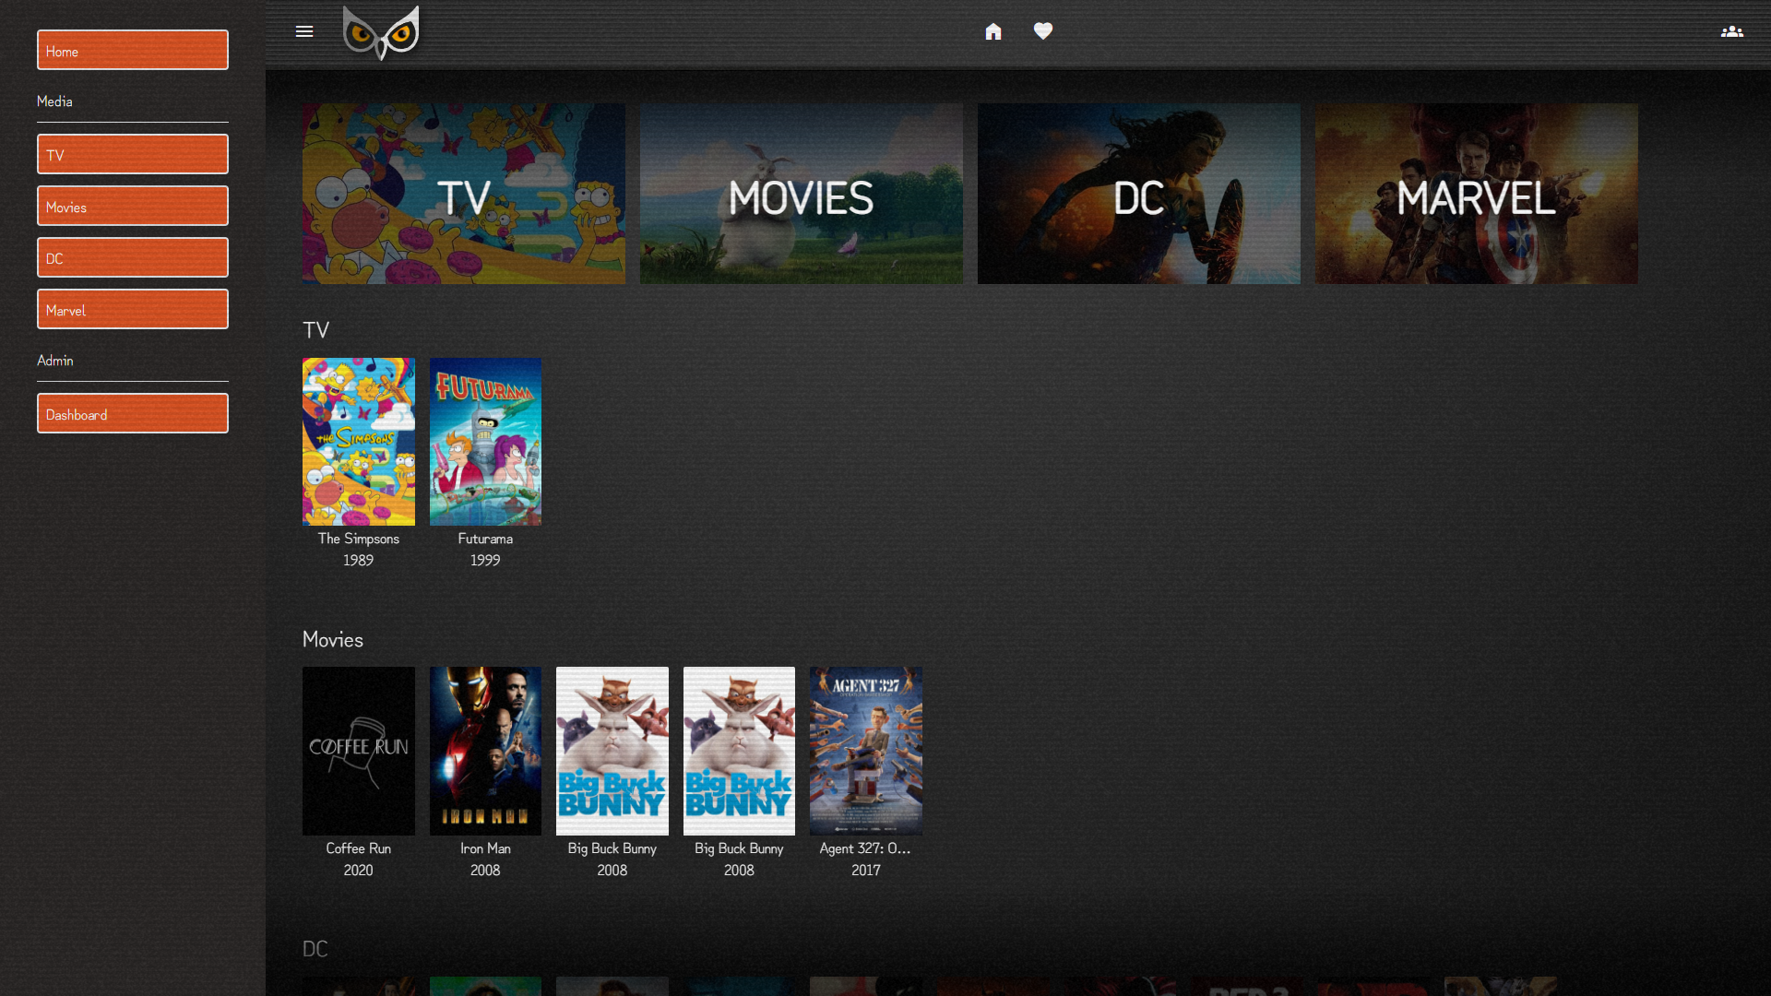

### Syncplay menu

Using this menu, users can create, join or leave a sync group. When users are inside a group, the user can go to the synced player from there.

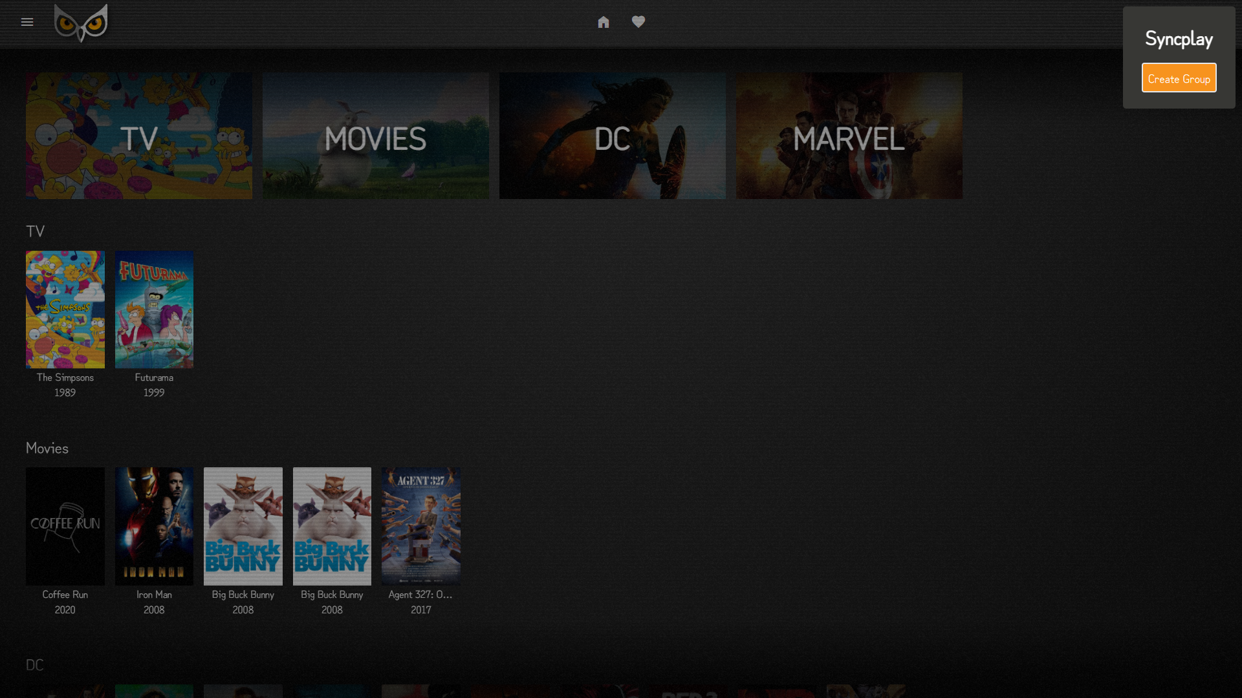

## Pages

### Homepage

Here the user can see existing libraries and their latest items.

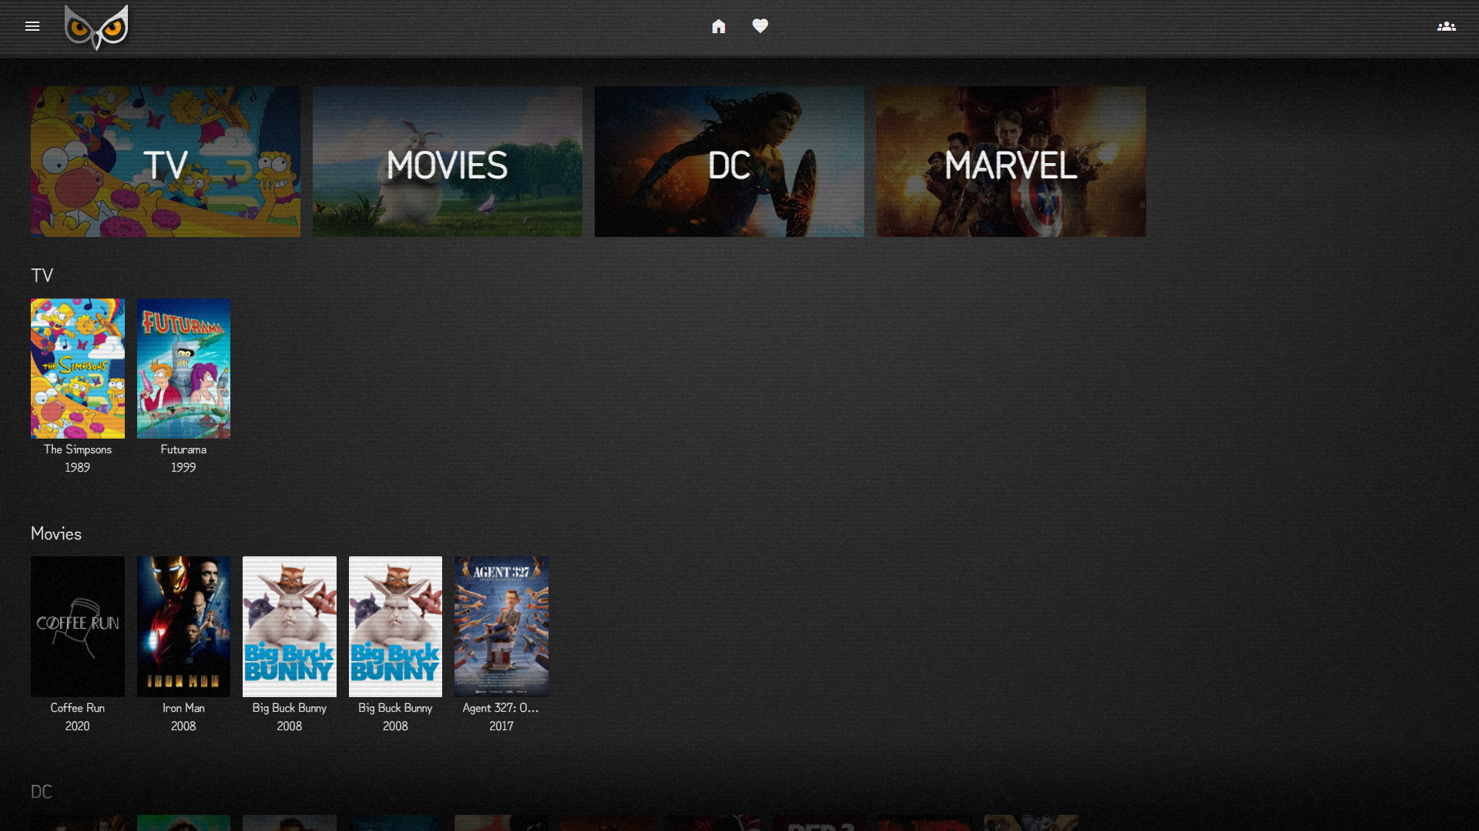

### Library

This page displays every item a library has across all the registered paths. A library can have one or many paths, and all of them will work as a single library.

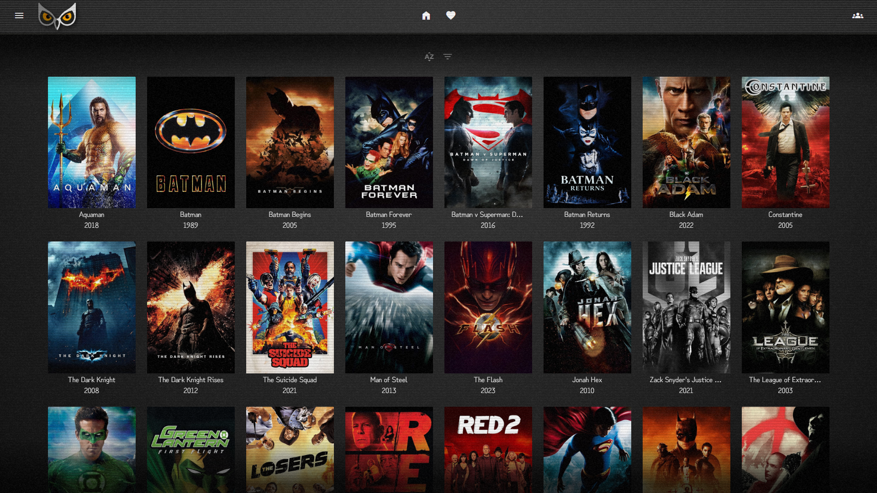

From this page, the user can sort the library to get a personalized view of items.

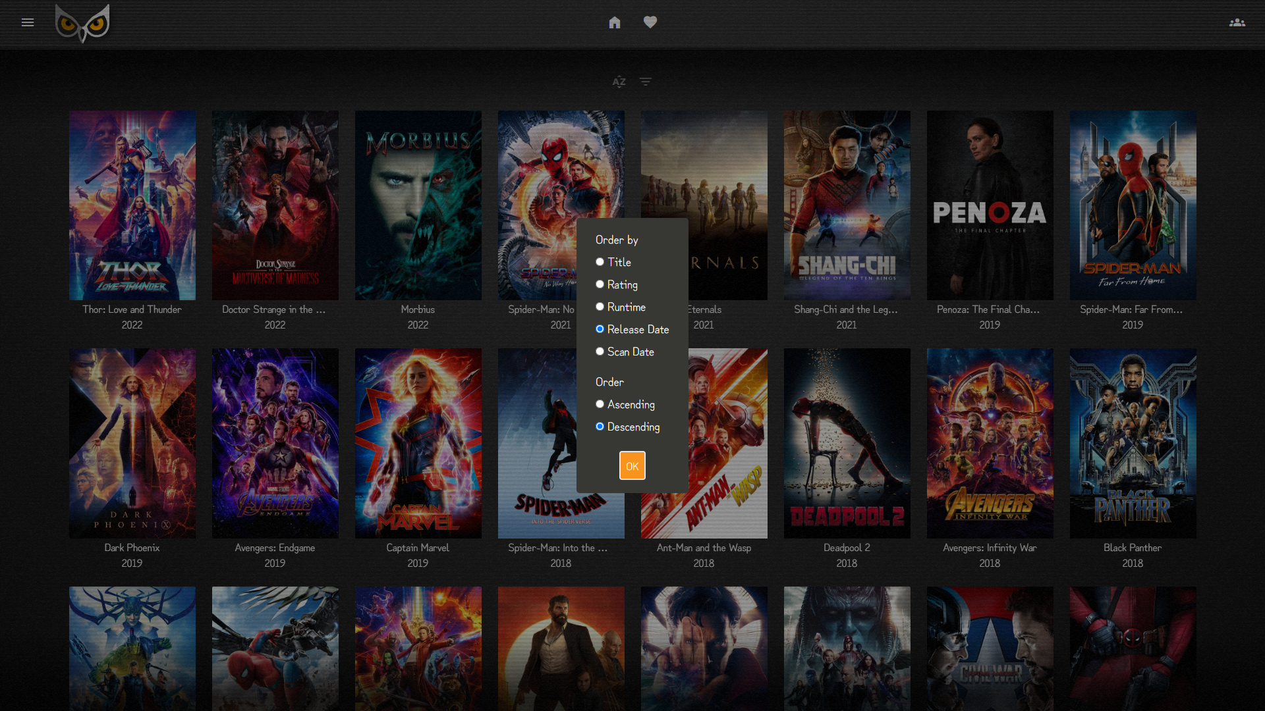

### Item details

Here a user can get details of an item like the title, release year, time on end of the playback.

Within this page, we can also see the credits, displaying director, writers and cast.

An item can be marked as favorited and/or watched.

Finally, the user can play the item itself, and this will go to the video player page.

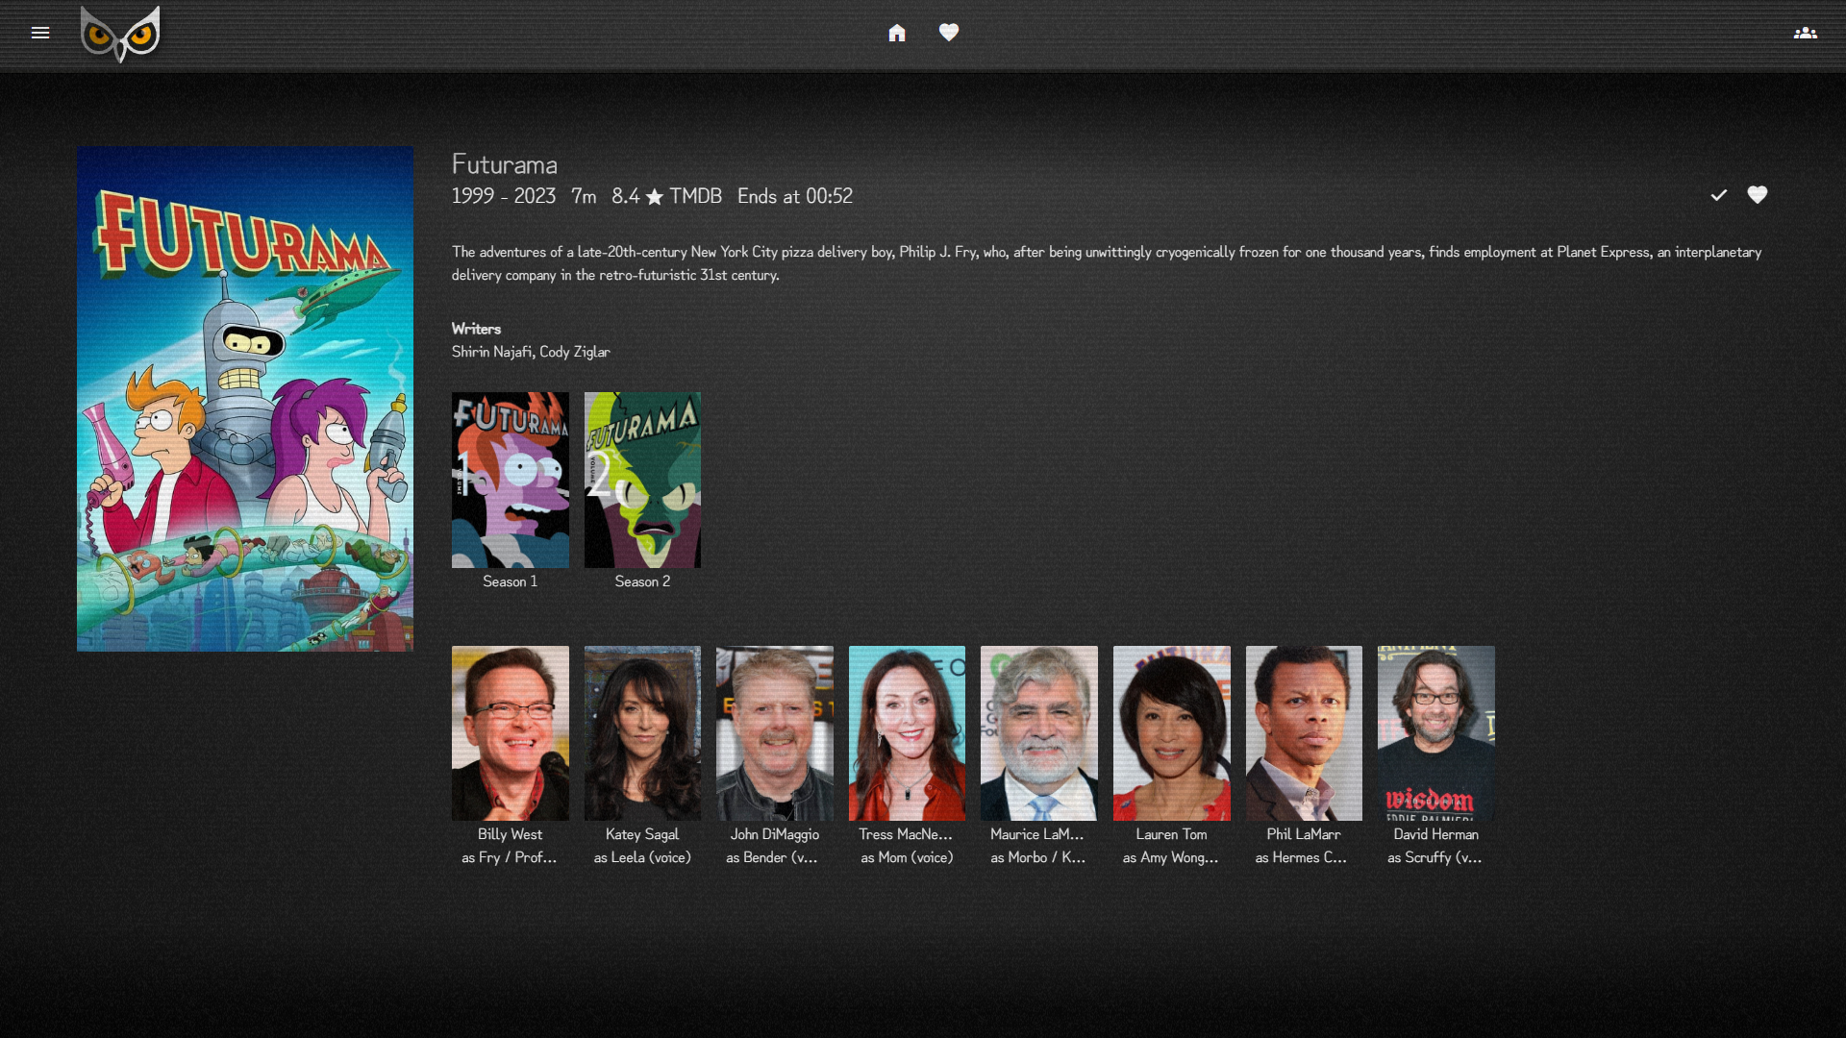

In case the item is a show (like this example), a list of owned seasons would be displayed. A season could also contain child items (episode), just like a show.

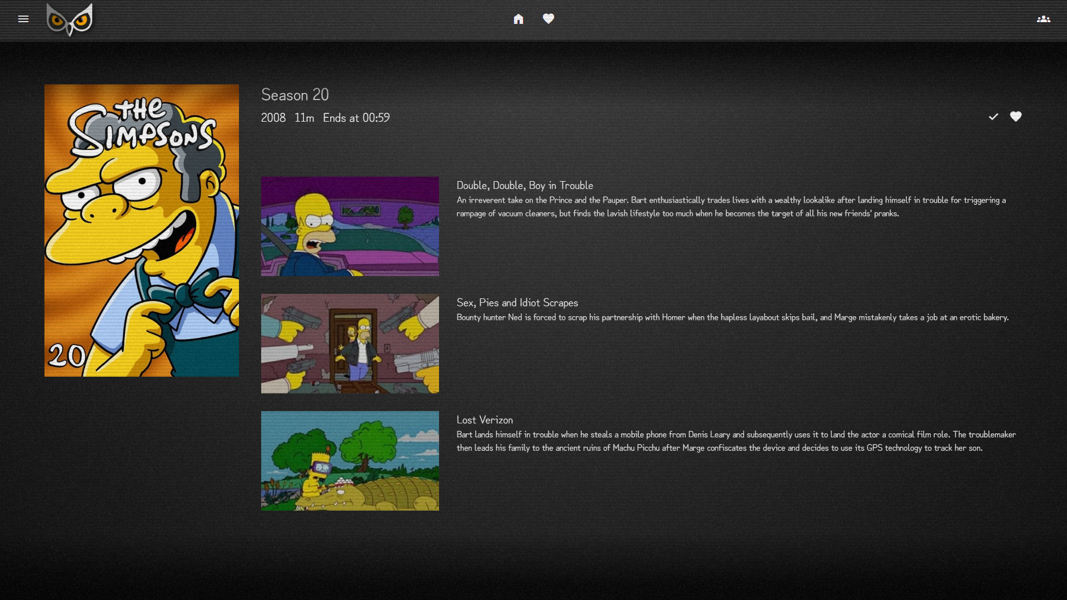

## Unit Testing

Although GO has a built-in testing package, there is no unit testing. There are a few **CMD programs** (located in **“cmd” folder** in code repo) that are used for **testing some** functionality but no close to what unit testing could be.

# Deployment

This section is very peculiar in our case. This is because **our project aims to be distributable for a normal user**, not only for developers. This makes the deployment really important, because **the easier the better for a user**.

Normally any web-based service needs lots of files or technologies installed on the running server in order for the service to work. In our case, we opted for GO because we can simply **bundle the whole project in a binary file** and **distribute it**.

Go also makes multi-OS builds easy, aiming Windows and Linux binaries without any hassle (even with macOS support).

A deploy, could be shipped as a binary file or a docker containing a binary file. For a demo instance, we choose to use a Dockerfile with a Docker Compose stack.

Everything described here can be found in the code repo.

This is the current (31/05/2024) deploy on <https://demo1.ovo.watch/>

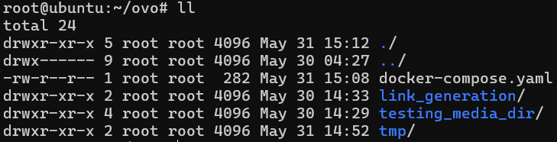

This is the deploy server folder structure. Containing a Docker compose, scripts for media generation, media directory, and a tamp folder.

This is the Docker compose:

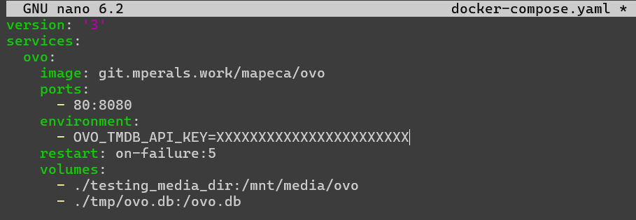

Here you can see, that this instance is using an SQLite database. In order to have persistence, we mount the media directory and the database file to the container. Also, we need the mandatory environment variables, that’s why there is the TMDB API key. As an extra, we put a restart on failure in case the server crashes, it will auto restart.

Media generation scripts:

Instead of filling the demo server with lots and lots of files, we simply uploaded a single video file, and used a script to generate hard links with different names provided from a text file.

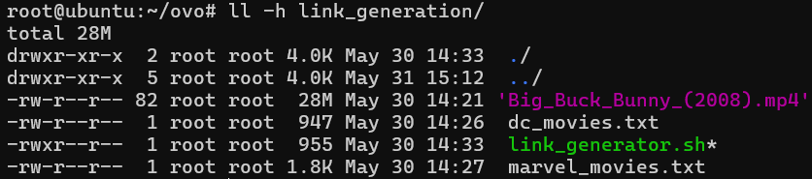

The “link_generator.sh” script, reads a text file line by line and creates a hard link for each line using a source file. The result of the script is something like this:

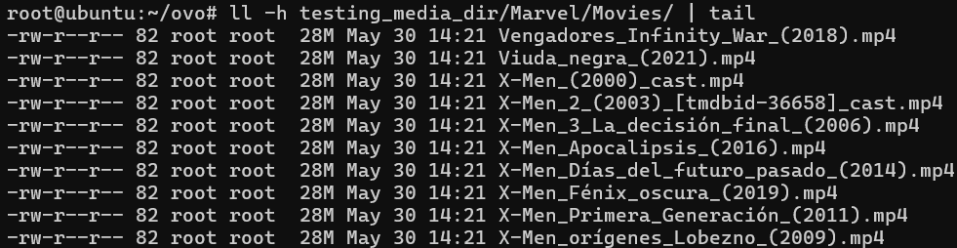

As you can see, every video file, has the same size. We can check the server disk usage to see the real size of the ovo directory.

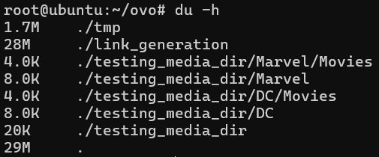

# Improvement proposals

Lots of improvements can be done. From the style to more features.

The most important could be, a track of the watched runtime of the content, social login (Google, Facebook, etc.), related items (similar movies or shows), search (items or people), user settings, user management (admin), user log (admin), server settings from the Ui instead of the .env file, and many more features.

# Conclusions

The result project was very close to the original proposal. We achieved a functional content library that can display the current content with external metadata and the user can play the content alone or in a sync vide player with friends and family. Although some things are not final, they are mature enough to be usable and enjoyable.

Personally, I learned a lot developing this project. From learning new technologies like SASS, to design a project to be distributable for end users. Surely, I’ll continue the developing of this project and continue to improve its state, or remaking things.

Things I would change, could be the frontend itself. It does not convince me to be enough and probably a new frontend will be created.

I also don’t quite like the server-side approach. Server-side render has many benefits like being accessible to many more devices due to its performance requirement, being SEO compliant, and many more. But I think that a pure dedicated frontend communicating with a backend could provide a more pleasant and enjoyable experience for a site like this one.

# Webography

## Documentation and help

* Tailwind: <https://tailwindcss.com/docs>
* SASS: <https://sass-lang.com/>
* SweetAlert2: <https://sweetalert2.github.io/>
* jQuery: <https://jquery.com/>
* GO Lang: <https://go.dev/>
* Echo: <https://echo.labstack.com/docs>
* Templ: <https://templ.guide/>
* TMDB API Docs: <https://developer.themoviedb.org/docs/getting-started>
* GO TMDB API: <https://github.com/ryanbradynd05/go-tmdb>
* GO FFmpeg Libraries:
* - <https://github.com/u2takey/ffmpeg-go>
* - <https://github.com/go-ffstatic/ffstatic>

## Tooling

* Git: <https://git-scm.com>/
* Go Lang: <https://go.dev/>
* NPM: <https://nodejs.org/en>
* Air: <https://github.com/cosmtrek/air>
* HeidiSQL: <https://www.heidisql.com/>
* Laragon (Used for ease database management): <https://laragon.org/index.html>
* Docker: <https://www.docker.com/>
* AI Assistance
  + Chat GPT (Used for problem solving): <https://chat.openai.com/>
  + GitHub Copilot (Used for boilerplate): <https://github.com/features/copilot>

## Resources

* GO Docker image building (Dockerfile)
  + <https://www.cloudbees.com/blog/building-minimal-docker-containers-for-go-applications>
  + <https://chemidy.medium.com/create-the-smallest-and-secured-golang-docker-image-based-on-scratch-4752223b7324>